WannaCry Version 2 Analysis Report
Overview
WannaCry is a ransomware that is classified as worm that combined file encryption methods with autonomous propagation. Unlike ransomware in the past that depends entirely on the user or phishing methods, WannaCry spreads through vulnerabilities in Windows systems over SMB. This allows it to move rapidly across internal networks after a single system is compromised.
This analysis focuses on WannaCry V2 payload sample named diskpart.exe. Reverse engineering of the sample identified persistence through Windows service creation, executing through cmd.exe, recursive filesystem staging, cryptographic validation logic, and evidence of multi-threaded behavior.

Background
WannaCry became one of the most disruptive ransomware outbreaks because it combines three dangerous characteristics.
- Remote exploitation of vulnerable systems
- Ransomware encryption behavior
- Worm-like propagation across networks
The malware is commonly associated with exploitation through EternalBlue and delivery through DoublePulsar, though the sample analyzed here is the payload itself rather than the exploit or implant stage. The analyzed code shows that once it is executed, the payload is structured, deliberately designed and reliability focused.

Attack stages
- Stage 1: Initial Compromise
WannaCry is commonly delivered after the exploitation of vulnerable SMB services. This gives the attacker remote code execution on the target host without ever requiring ordinary user interaction.
- Stage 2: Payload Delivery
The ransomware payload is delivered onto the compromised host; the analyzed sample reflects this payload phase rather than the exploit phase.
- Stage 3: Execution
The malware used Windows command execution to run its payload. In the analyzed sample it is visible through the construction of a command string using cmd.exe.
- Stage 4: Persistence
The malware opens the Windows Service Control Manager, checks for a service, creates one if needed, and then starts it. This allows malware to have durable execution and an elevated context.
- Stage 5: Filesystem Preparation
The malware checks directories, and makes them if they are missing, and recursively builds intermediate paths. This allows support for staging components and operational artifacts.
- Stage 6: Encryption Preparation
The malware validates parameters using strict size checks consistent with the standard cryptographic lengths. This has a strong implication that structured encryption routines are happening rather than improvised logic.
- Stage 7: Concurrent Activity
The presence of synchronization APIs suggests that multi-threaded execution is used. This could potentially improve the speed of encryption or propagation.

Technical Findings with Code Evidence
Windows Service Persistence
The sample interacts with the Windows Service Control Manager to create and launch a service.
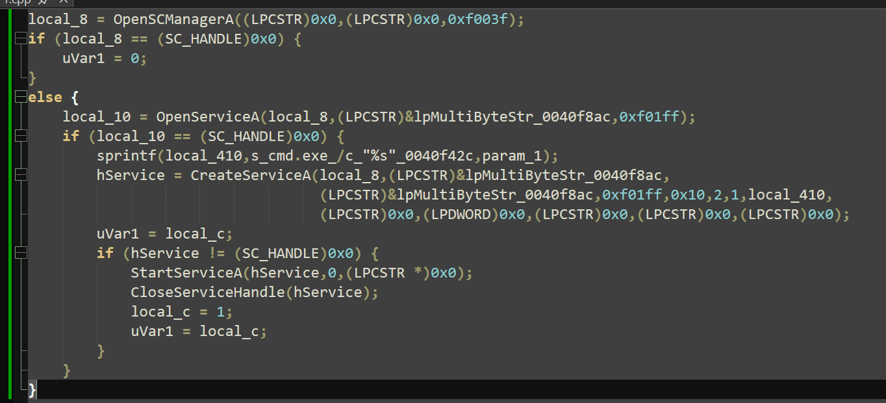
Analysis
This code shows the malware opening the Service Control Manager, attempting to access an existing service, constructing a command string using cmd.exe /c, creating a service if necessary, and starting it. This behavior supports persistence and reliable execution.
Malware establishes persistence through Windows service creation. It uses OpenSCManagerA, OpenServiceA, CreateServiceA, and StartServiceA to install and launch itself as a service, enabling continued execution and elevated context.
Command Execution Through cmd.exe
sprintf(local_410,s_cmd.exe_/c_"%s"_0040f42c,param_1);
Analysis
This shows the payload being executed through the Windows command interpreter. This provides a flexible and familiar execution path within the operating system.
The malware executes its payload via cmd.exe /c, allowing the ransomware to invoke Windows-native execution behavior and stage its actions through the command interpreter.
Code Evidence
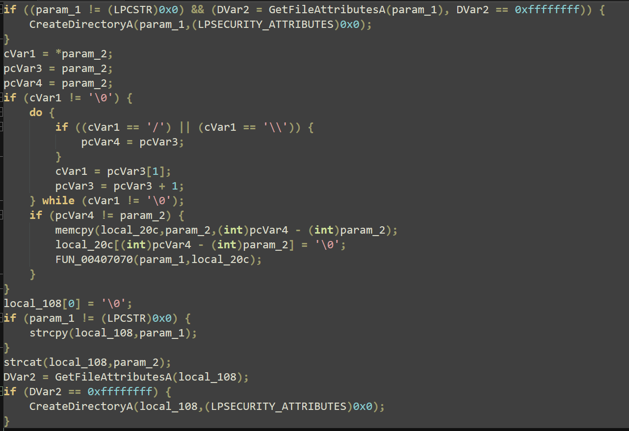
Analysis
This function checks whether a directory exists, parses path separators, constructs intermediate path segments, and recursively ensures directories are created. This is reliable staging logic rather than a simple one-folder creation call.
The malware implements recursive directory creation using GetFileAttributesA and CreateDirectoryA. It parses path separators and builds intermediate directories as needed, ensuring the filesystem environment is prepared before staging ransomware components or artifacts.
Cryptographic Parameter Validation
The sample contains strict size enforcement that strongly suggests encryption-related setup.
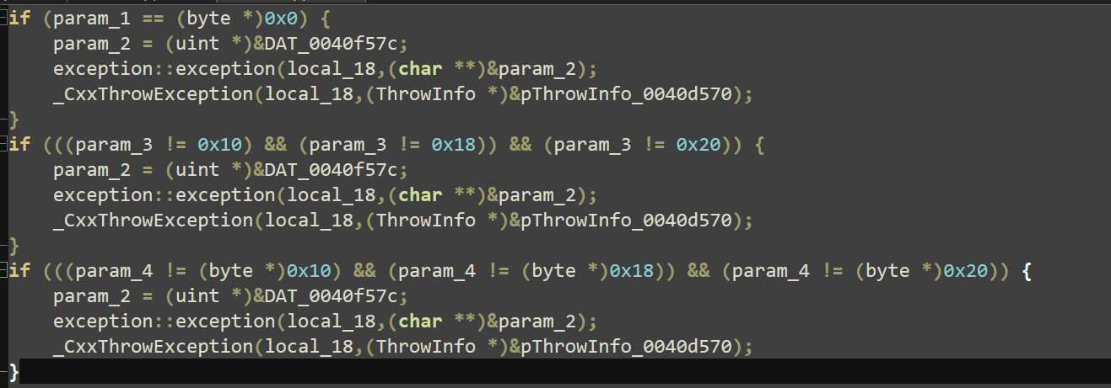
Analysis
The code rejects null input and only permits values of 16, 24, or 32 bytes. These align with common symmetric cryptographic lengths of 128-bit, 192-bit, and 256-bit. The use of _CxxThrowException indicates structured exception-based error handling.
The malware includes strict parameter validation consistent with cryptographic setup routines. Buffer or key sizes are restricted to 16, 24, or 32 bytes, and invalid values trigger _CxxThrowException, indicating deliberate control flow and stable encryption preparation.
Multi-threading and Synchronization
DeleteCriticalSection(...)
Analysis
Critical section management is used in multi-threaded programs to control access to shared resources. The presence of this API suggests the malware coordinates concurrent activity, which may support faster encryption or parallel execution.
The presence of critical section management indicates multi-threaded behavior. This supports the interpretation that the malware coordinates concurrent operations during execution, improving efficiency and reliability.
Masquerading
Evidence
The sample was labeled as diskpart.exe.
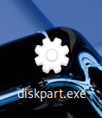
Analysis
diskpart.exe is the name of a legitimate Windows utility. Reusing that name is consistent with masquerading behavior intended to reduce suspicion and blend into system activity.
The malware uses deceptive naming, including diskpart.exe, to imitate legitimate Windows binaries and reduce the likelihood of immediate detection.
Indicators of Compromise (IOCs)
File and Process Indicators
- suspicious executable named diskpart.exe
- cmd.exe spawning malware execution
- unexpected service-backed process execution
- possible encrypted file extensions such as .WNCRY or .WCRY
Service Indicators
- newly created or suspicious Windows service
- service image path invoking cmd.exe /c <payload>
- service creation followed by immediate start
Filesystem Indicators
- unexpected nested directory creation
- new folders created recursively prior to ransomware activity
- staging paths built before payload actions
Behavioral Indicators
- service creation through Service Control Manager APIs
- directory existence checks followed by recursive folder creation
- cryptographic parameter validation with 16, 24, or 32 byte size enforcement
- use of critical section management suggesting concurrent execution
Network Context
- SMB-related compromise context is consistent with WannaCry operations
- rapid spread behavior would align with network scanning and propagation on vulnerable systems
YARA Rule
Here’s a practical report YARA rule based on the behavior and strings you found. This is not meant to be perfect across every variant on earth; it is meant to be a strong analysis artifact for your report and can be tuned later.
rule WannaCry_V2_Service_Persistence_Staging
{
meta:
author = "Tyler"
description = "Detects WannaCry-like payload behavior based on service persistence, cmd execution, directory creation, and crypto validation context"
date = "2026-04-08"
family = "WannaCry"
version = "V2-focused behavioral rule"

strings:
$s1 = "OpenSCManagerA" ascii
$s2 = "OpenServiceA" ascii
$s3 = "CreateServiceA" ascii
$s4 = "StartServiceA" ascii
$s5 = "CreateDirectoryA" ascii
$s6 = "GetFileAttributesA" ascii
$s7 = "DeleteCriticalSection" ascii
$s8 = "cmd.exe /c" ascii
$s9 = "diskpart.exe" ascii
$s10 = "_CxxThrowException" ascii

condition:
uint16(0) == 0x5A4D and
6 of ($s*) and
$s8 and
1 of ($s3,$s4) and
1 of ($s5,$s6)
}
YARA Explanation
- uint16(0) == 0x5A4D checks for a PE file.
- cmd.exe /c reflects your execution finding.
- service-related APIs reflect persistence.
- directory APIs reflect staging.
- DeleteCriticalSection supports threaded behavior.
- _CxxThrowException supports your structured crypto-validation finding.
- diskpart.exe supports masquerading, though that string may not always appear in every sample.
A behavioral YARA rule was developed using the reverse engineered sample’s service creation, command execution, directory staging, threading, and exception-handling artifacts. The rule focuses on payload behavior rather than relying only on a single static filename.

Detection Notes
This sample appears designed for reliable execution rather than noisy instability. Its use of service creation, recursive directory handling, and parameter validation suggests the developers prioritized controlled behavior and resilience. Those traits make behavioral detection more valuable than relying on a single filename or hash alone.
Conclusion
The analyzed WannaCry V2 payload demonstrates a structured ransomware design with persistence, filesystem staging, command-based execution, cryptographic parameter enforcement, and concurrent execution support. Reverse engineering shows that the malware is not merely a simple file-encrypting program, but a deliberately organized payload built for reliability and scale.
The strongest findings in this analysis were the service creation logic, the cmd.exe execution path, the recursive directory creation routine, and the strict 16/24/32-byte parameter validation consistent with encryption setup. Together, these findings provide both technical insight and practical detection value.

